***Factory Profile***

[](http://red-ofashion.com/)



**Md. Mohon Shaikh**, Managing Director

**Information about Managing Director**  
Mr. Mohon Shaikh, studied Master of Social Science in Political Science and completed a MBA on garments/textile & started to work in the garment industry (Factory & Buying House) in 2005.

**Message of Managing Director**  
“We are proud to introduce ourselves as a source agency working successful Asian, European and American garments buyers. We have achieved to reach the best standards in terms of quality, merchandising and production, allowing us to offer you the best service at the most reasonable price. For each customer we have individual Merchandiser + QA for follow up development/sampling stage to shipment. So that team can increase their turn over & understand their work well. We are very honest in front of our customer, maker and advise both part to provide honest information.  
“our customer’s demands deserve highest priority from our side.”

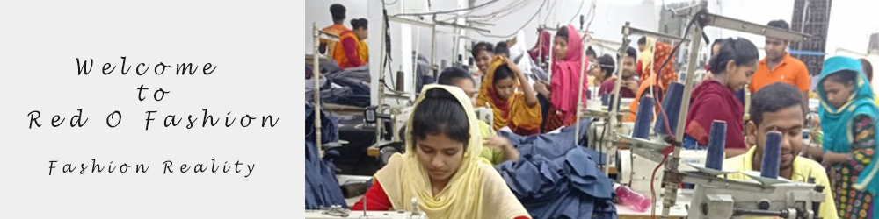

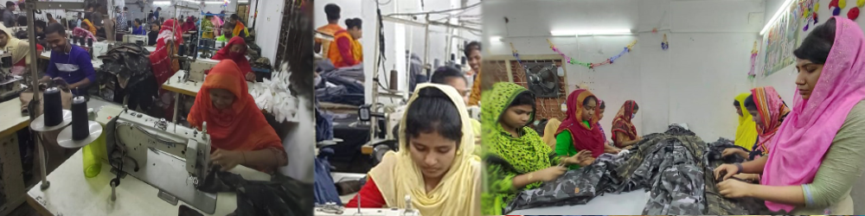

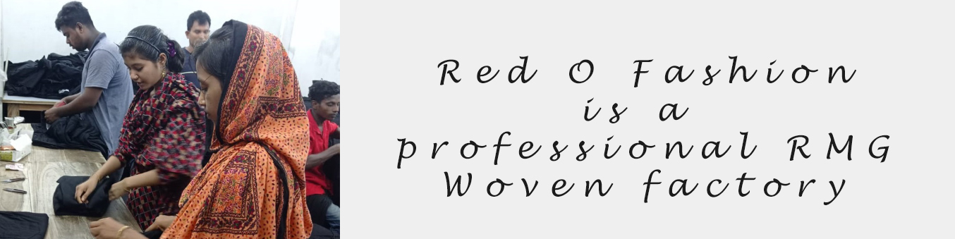

Red O Fashion is a manufacturer of ready-made garments in Bangladesh. We are doing garments product with our current buyers knitted & woven. Through good communication, excellent working relationships and reacting to our customers need, we have developed unique, effective, reliable and professional operating structure and sourcing concept that ensures we retain our position in the Asian, USA & European market. We have high skill & experienced merchandisers, QA and Commercial team. As per our capacity & capability we take order to perfect execution. Our major clients are Asian buyer, Marc-Lauge -Denmark, Mischief – USA, Tespol- Poland

Red-O Fashion has also own trade licence, IRC & ERC. All members are giving it’s best quality to export RMG products. It has available employees for achieving goodwill. The company produces most fashionable products Like: Danim, Jinn’s, Boys jogger, Men’s joggers Chinno long,/shorts & others.

*Factory information*

*This factory has every machine for making good quality product.*

*List of machineries*

*1 plain m/c lock stich 60*

*2 over lock 5 thread 13*

*3 over lock 4 thread 6*

*4 flat lock 4*

*5 eyelet hole 5*

*6 feed of the arm 3*

*7 kansai 6*

*8 chain stich 11*

*9 two needle 12*

*10 button attach auto 4*

*11 bartek m/c 4*